When Shadows Rise: The Mysterious Creatures Emerging from the Deep Sea
An exploration of Strange and mysterious deep-sea creatures, which are appearing near the surface, revealing the secrets of the ocean’s hidden world.
For thousands of years, the deep sea has been a place of mystery and amazement, a pitch-black world stretching thousands of meters below the surface, shrouded in eternal darkness and mystery. But in recent years, something strange has been happening. The deep is stirring. Creatures once hidden in its unfathomable depths are beginning to appear in our world above—on shores, in fishing nets, even in viral videos. The question is, why?
The Oarfish: A Sign from the Ocean
It began with eerie sightings—bizarre creatures surfacing from the abyss. Among them, the Sea Devil. A monstrous fish with a dangling light on its head, it lures prey into its gaping jaws with ghostly bioluminescence. But this isn’t a fantasy. It’s real. And it's not alone.
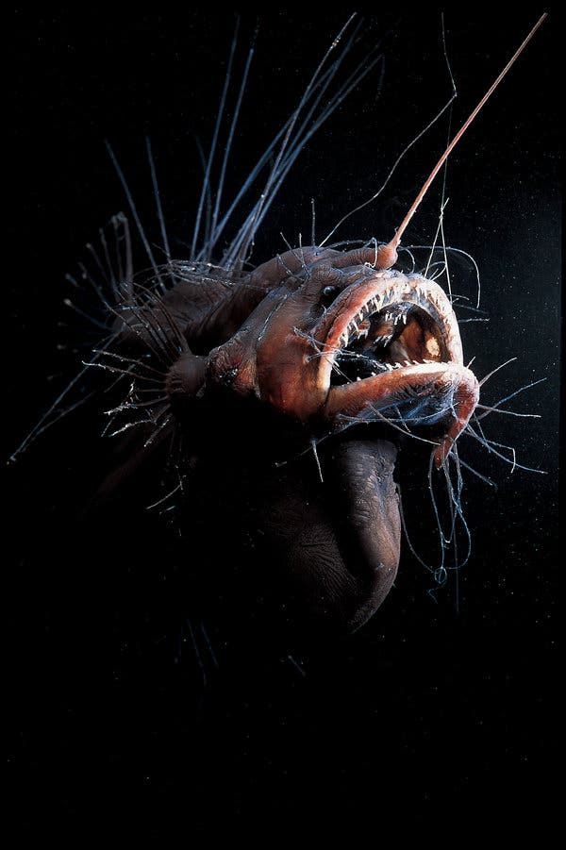
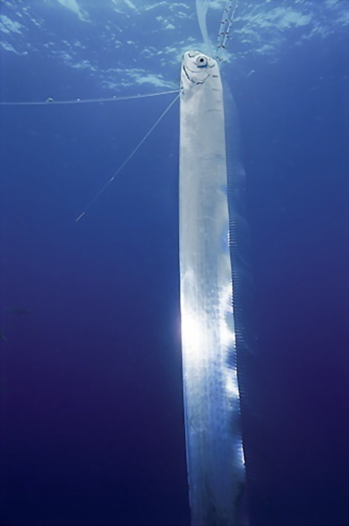
In January 2023, a Japanese fisherman hauled in a 6-meter-long creature resembling a silver-white serpent. Sticky, rubbery, and unsettling—he had caught a Deep-Sea Oarfish, a species usually found a kilometer beneath the ocean’s surface. He threw it back, not out of kindness, but fear. For in Japanese folklore, the oarfish is a harbinger of disaster—an omen of impending earthquakes.
Deep-Sea Oarfish
Sea Devil
It’s not just myth. In 2011, shortly before Japan’s catastrophic earthquake, nearly 20 oarfish were found dead on its shores.
But here’s the twist: similar sightings are happening across the globe. In 2023, 50 oarfish were caught at once. In 2024, California saw three surfacing. In February 2025, a live one appeared in Mexico. These ghostly giants are surfacing more than ever before—and they aren’t alone.
Aliens Among Us: The Deep’s Most Bizarre Inhabitants
The deep sea is Earth’s final frontier. 71% of our planet is covered in water, yet only 5% of our oceans have been mapped or explored. In fact, we know more about the surface of Mars than we do about our own ocean floors.
Descend past 200 meters, and sunlight fades. Red vanishes first, then orange, yellow, green, until only blue and violet remains. Below 1,000 meters—the Midnight Zone—no sunlight penetrates. And in these depths, life gets weird.
Take the Barreleye Fish, with a transparent head and eyes that look upward through a dome. Or the Strawberry Squid, with one large eye to spot predators above and one small eye to detect bioluminescence below.
There’s the Sea Angel, a graceful glowing creature that turns deadly in seconds. The Giant Phantom Jellyfish, whose tentacles stretch over 10 meters. And the Dumbo Octopus, flapping its big, ear-like fins like a ballerina in the abyss.
Let’s not forget the Vampire Squid, a 200-million-year-old relic that doesn’t suck blood—but feeds on marine snow, detritus drifting down from above.
Then there’s the Yeti Crab, which grows food on its own arms—farming Sulphur-loving bacteria in a deadly dance near hydrothermal vents.
Even more haunting is the Scaly-Foot Snail, with iron-plated legs and the largest heart (relative to body size) in the animal kingdom. This isn’t a fantasy tale. These creatures are real. Many of them are only now being discovered. And many could disappear before we even know their names.
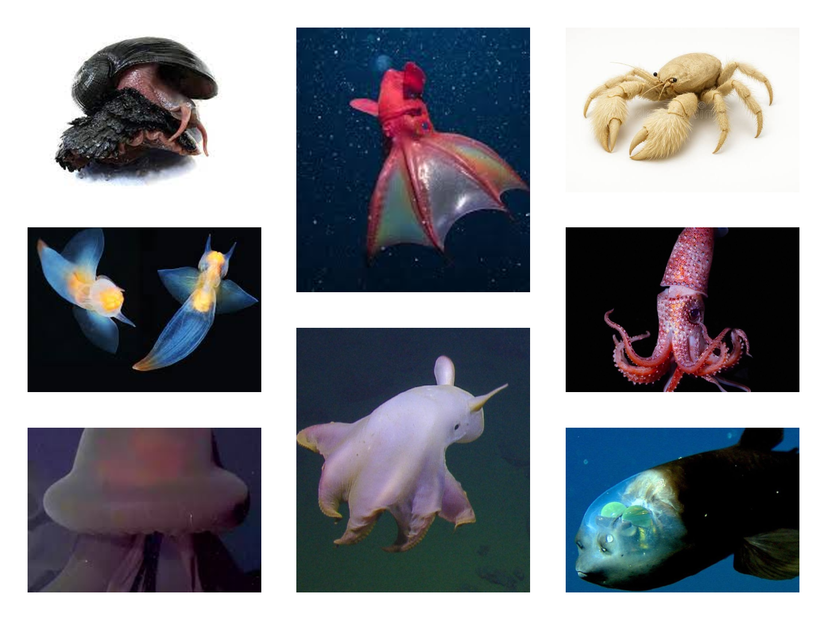
Strawberry Squid
Barreleye Fish
Dumbo Octopus
Giant Phantom Jellyfish
Sea Angel
Yeti Crab
Vampire Squid
Scaly-Foot Snail
The Mystery of the Rising Deep
Why are they rising?
The answer may lie in one of Earth’s largest, yet invisible events, the Diel Vertical Migration (DVM). Every night, billions of deep-sea creature’s swims upwards to feed under the cover of darkness, only to descend again before dawn. It’s the largest daily migration on Earth, invisible to the human eye.
But this delicate rhythm is now being disrupted. Climate change is warming up our oceans. As surface waters heat and oxygen becomes scarcer in depth, creatures are being forced upward—not for feeding, but for survival.
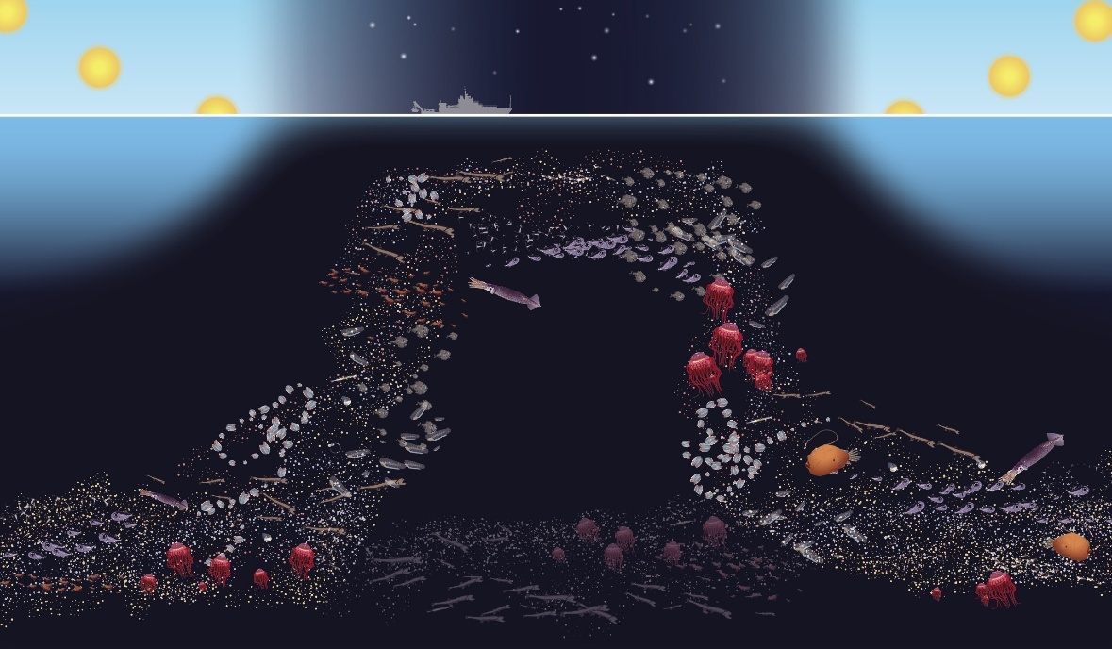
And that’s dangerous. These organisms are adapted to darkness, pressure, and cold. Up here, they face predators, heat, and light they were never meant to endure. Scientists estimate that deep sea creatures are now migrating 4 to 11 times faster than those near the surface.
Diel Vertical Migration (DVM)
It’s a desperate exodus. One that might not end well.
Mining the Abyss: A New Threat
As if climate change weren’t enough, deep sea mining looms on the horizon. Corporations are eyeing the ocean floor—not for discovery, but destruction. Massive machines are being designed to extract gold, silver, and rare earth metals from delicate hydrothermal ecosystems.
Innocent beings like the Scaly-Foot Snail—found in only three locations on Earth—could be wiped out before we even understand their role in our planet’s story.
Despite global protest, pressure mounts. The International Seabed Authority, a UN body, is being lobbied to grant mining licenses. Thirty-two nations have said “no.” Greenpeace’s petition to “Stop Deep Sea Mining Before It Starts” has gained over 3 million signatures. But is it enough?
Why This Matters—To All of Us
The deep sea doesn’t just belong to mysterious creatures—it’s part of the planetary engine that keeps Earth livable. Tiny phytoplankton in sunlit waters, supported by nutrients from the depths, absorb carbon dioxide, regulate climate, and form the base of the food chain.
If we destroy the deep, we unravel the threads that keep our atmosphere stable, our climate balanced, and our oceans alive.
A Final Thought
As Mahatma Gandhi once said,
“The world has enough for everyone’s needs, but not for everyone’s greed.”
The deep sea is ancient, alien, and awe-inspiring. It doesn’t need us. But we need it.
And now, as these creatures begin to rise—perhaps as omens, perhaps as warnings—we must ask ourselves:
Will we listen before the silence of the deep becomes permanent?

Author:
Fahim Ahmed Chowdhury
3rd Year Student
Department of Oceanography
Shahjalal University of Science and Technology (SUST), Sylhet

